**CSc 110 Lab 3**

For-Loops, what's going on:  
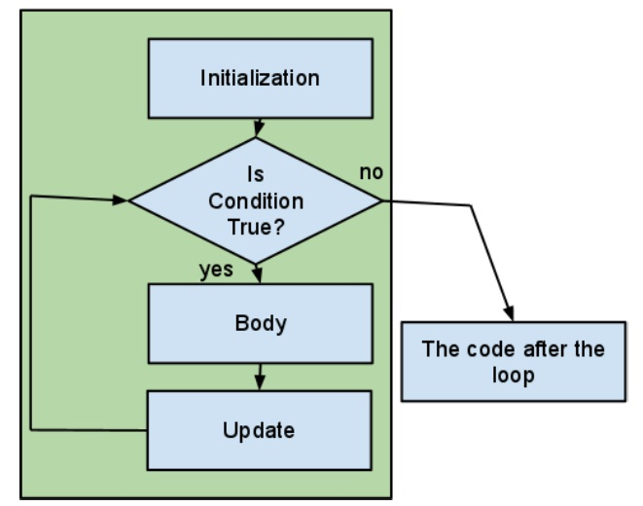

In these 2 hours of lab you will be practicing with **methods** and **loops**.

Methods:

1. They are sub programs that separate some of the actions that a program performs.  You can recognize the call by the presence of brackets.   
     
   System.out.println() is a call to a method.
2. Much of the time a method is given one or more values from the program that calls it.  These are called paramenters.  Parameters are copied and the copies are employed in some way by the subprogram.   
     
   printTransaction(amount, kind, date, balance);
3. Often we want a method to return some value.  In its simplest form the value is the result of some calculation that we may make many times in the calling program and don't wish to repeat the code over and over.  The returned value is usually captured as part of a larger expression or as part of a simple assignment.   
     
   double area = computeArea(dim1, dim2)  
   double volume = compVol(dim3, area);

New programmers must learn to imagine that a method exists before they code it and to see it's place in a larger program.  This ability comes with practice.  Most of you would already know what the methods referred to in 2 and 3 above must do.  
  
**Learn to quickly write a correct method header (first line).**   
  
A correct header for the method referenced by *2* above is given.  Look at it then do the same for the methods referenced in *3* above:

public static void printTransaction(double amount, String transaction, String dateStr, double bal)  
  
To be correct printTransaction must be called with 4 parameters  a double, a String, a String, and a double, no different order or different number parameters will match this signature.   
  
Note: Since the parameters are copied for use in the method the names can be the same or they can be different.  When a new programmer learns to recognize the need for a sub program,  'a cog' in a solution and writes the sub program first, the names are likely to be different.  When the subprogram is written just as it is needed the parameter names are likely to be the same.  In this example the mapping of the parameters from the caller to the method is:

* amount -> amount
* kind -> transaction
* date -> dateStr
* balance -> bal

**Exercises**

**Practice, practice, practice.**

Your TA may ask you to just share the experience with someone beside you if we can't quickly fix the errors that result. You can always come back and do the demo and more experiments on your own.

***Example 1:***

Type in:

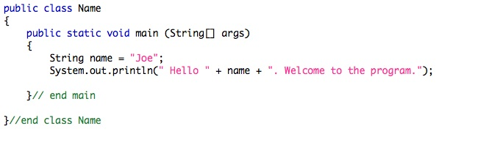

Compile and run the program.

***Example 2:***

Add a simple method to print the name: See what happens when the String name is defined in the main instead of the method. Note the error. Is the error a compile time or run time error? Are there work-arounds? What is the best solution?

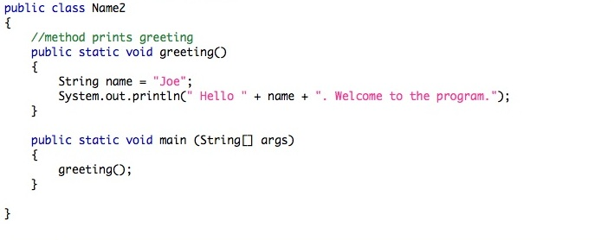

Compile and run the program

***Example 3:***

Add a parameter to your simple method. What is the benefit of doing this. Generate a *compile-time error* by moving the declaration of name from the main to the method.

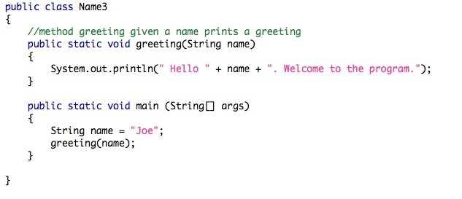Compile and run the program

***Example 4:***

Add a second method with two parameters.

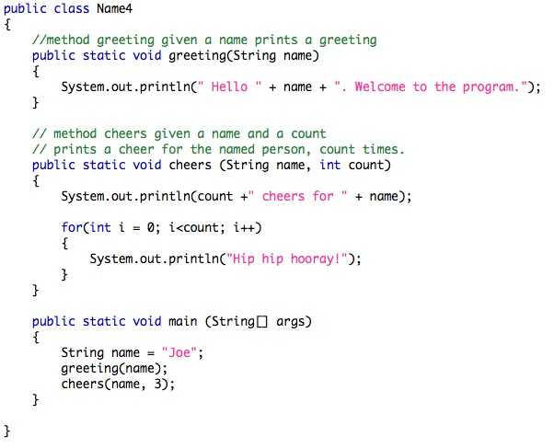

Compile and run the program

**Continue with the following exercises:**

***Exercise 1***

Download this [Song.java](http://webhome.csc.uvic.ca/%7Ecsc110l/2012_5/Lab3/code/Song.java) and fill in the main method.

***Exercise 2***

Type in the following program and fill in the main method.

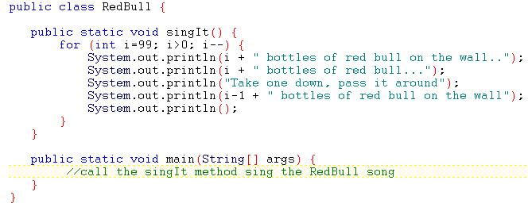

Continuing with this exercise...

1. Fix the grammar errors that occur in the output of the song.  
   HINT: what is output when one bottle or no bottles are left?
2. Add a parameter to vary the number of bottles that start on the wall.

***Exercise 3***

Download [Time.java](http://webhome.csc.uvic.ca/%7Ecsc110l/2012_5/Lab3/code/Time.java) and compile and run it.

Try adding a **return value** to the *calcDuration* method and move the print statement into to the main method.

***Exercise 4: Review***

Download [Loop.java](http://webhome.csc.uvic.ca/%7Ecsc110l/2012_5/Lab3/code/Loop.java) and compile and run it.

Answer the questions in the comment after the program.

The End

**Exercise 4 Answers**

1) What is the output?:  
1 2 3 4  
  
2)  (while loops will be covered next lab)

3) What is the name of the loop variable?  
i  
  
4) What is the type of that loop variable?  
int  
  
5) Give the method header (or method signature) in the program.  
public static void main(String [] args)  
  
6) Is this a procedural or functional method?  
procedural  
The method does not return anything (the return type is void).  
  
7) What is the name of the method?  
main  
  
8) What is the name of the parameter taken by the method?  
args  
The parameter type is a String array, but we haven't learned about those yet.